**Unit 3 Graded Exercise 2**

The following questions come from the “Check your understanding” examples of each section of chapter 8 in your textbook.

After you are finished, please submit a Microsoft Word file that contains screenshots of the SQL Queries, the output, and put a comment line in the query with your last name. Your document should be named **U3_GradedExercise2_Lastname.docx**.

(8-2) Question 1:

Create a check constraint on the *hire_date* column of the *sec0802_employees* table. Check that the *hire_date* comes after 1995.

(8-3) Question 2:

Put a uniqueness constraint on the *department_name* field of the *sec0803_dep*  *artments* table.

(8-4) Question 3:

Make the *last_name* column a required field in the *sec0804_employees* table.

(8-5) Question 4:

Put a primary key constraint on the *sec0805_departments* table. Define the primary key to be the *dept_code* field.

(8-8) Question 5:

Set up RI between the *sec0808_departments* table and the *sec0808_employees* table. The *sec0808_depatrments* table contains a list of all the valid values of the *dept_code* field.

(8-9) Question 6:

There is already an RI relation between the *sec0809_departments* table and the *sec0809_employees* table. Write an SQL insert statement and an *update* statement on the *sec0809_employees* table that will be rejected because of RI.

Hint: Use a value of the *dept_code* field that is not one of the valid codes listed in the *sec0809_departments* table.

(8-11) Question 7:

There is already an RI relation between the *sec0811_departments*table and the *sec0811_employees* table. Write an SQL update statement and a delete statement on the *sec0811_departments* table that will be rejected because of RI.

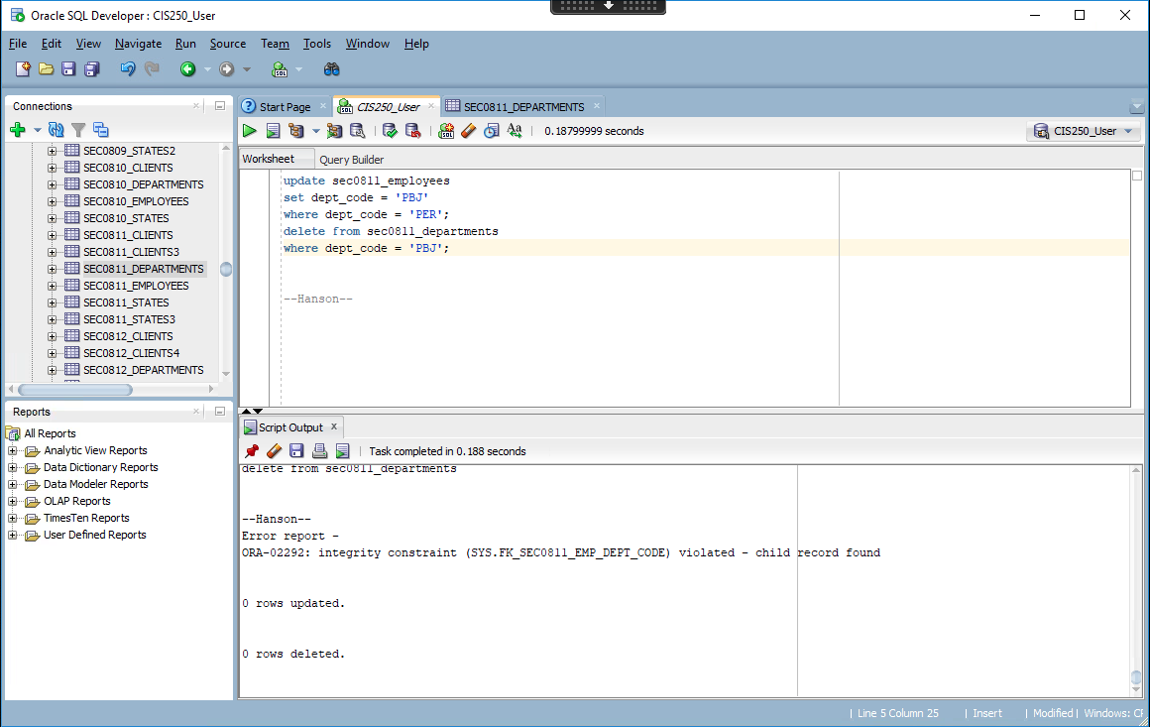

(8-17) Question 8:

Set up RI between the *sec0817_departments* table and the *sec0817_employees* table. Handle deletes using the set null rule. Then show the effect of this rule by deleting the shipping department from the *sec0817_departments* table.

(8-19) Question 9:

Set up RI between the *sec0819_departments* table and the *sec0819_employees* table. Handle updates using the cascade rule. Then show the effect of this rule by changing the shipping department code in the *sec0819_departments* table from *SHP* to *ABC*.

Not sure if this was a trick question but it says oracle does not handle sql updates.